Build a CI/CD pipeline

Table of Contents

Prerequisite: 3
Walkthrough: 3
Part 1: Implement simple CI/CD Pipeline 3

In this activity, you will implement a CI/CD pipeline using GitHub Actions — one of the most accessible tools for introducing DevOps concepts. You'll start with a basic static website (HTML files) and automate the process of validating, packaging, and deploying it to GitHub Pages.
The pipeline will include five stages that reflect key DevOps practices: code checkout, syntax validation, link checking, build preview, and automated deployment. By completing this activity, you’ll get hands-on exposure to continuous integration and delivery, version control workflows, and automated quality checks — core pillars of DevOps.
This activity demonstrates how even a static site can benefit from DevOps automation, setting the stage for scaling these practices to more complex applications and cloud-native deployments.

Prerequisite:
- GitHub Account ( https://github.com/login )

Walkthrough:
- Implement simple CI/CD Pipeline

Part 1: Implement simple CI/CD Pipeline
1 | Navigate to the repository provided by trainer & fork it.  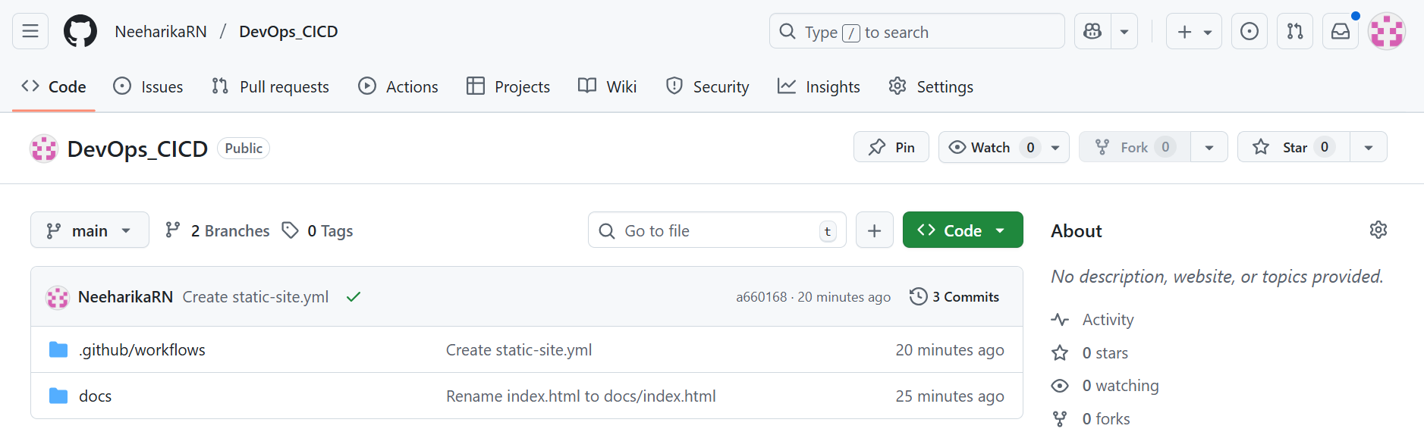  Navigate to “Settings”.  In the left panel, click on “General” under “Actions”.  Scroll down to the “Workflow Permissions”, Select “Read and write permissions” and check the box “Allow GitHub Actions to create & approve pull requests”.  Click on “Save”.  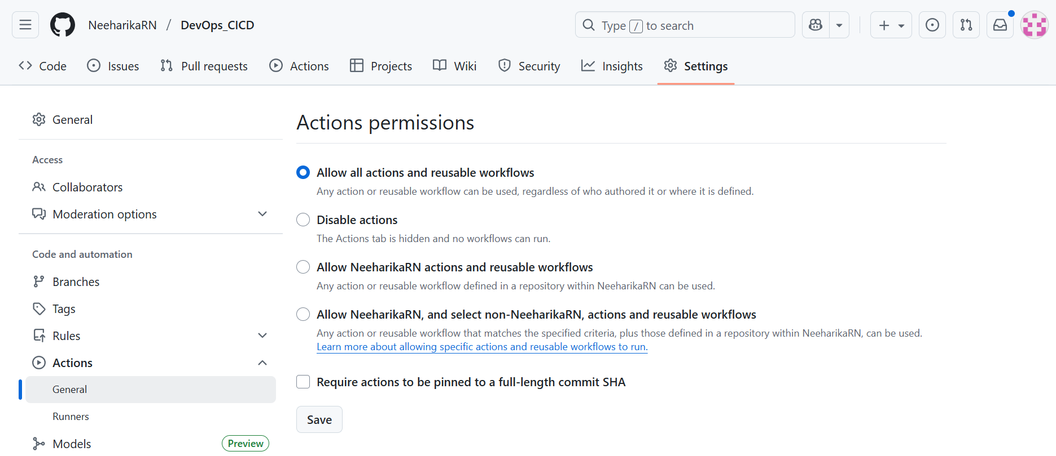  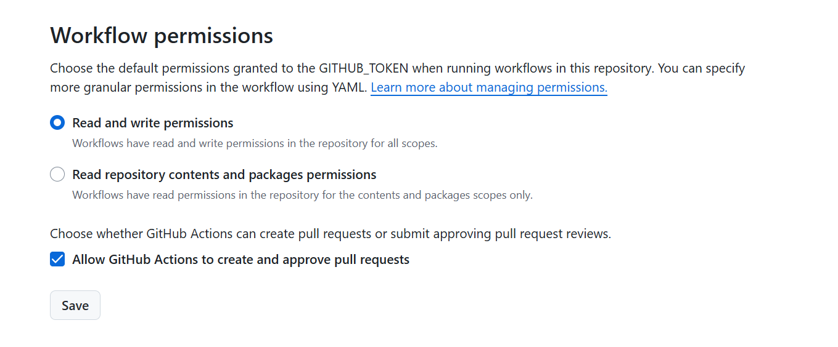  After successful fork, check if the workflow was executed. If not, perform a small edit ( like adding a file ) and then observe the “Actions” tab.  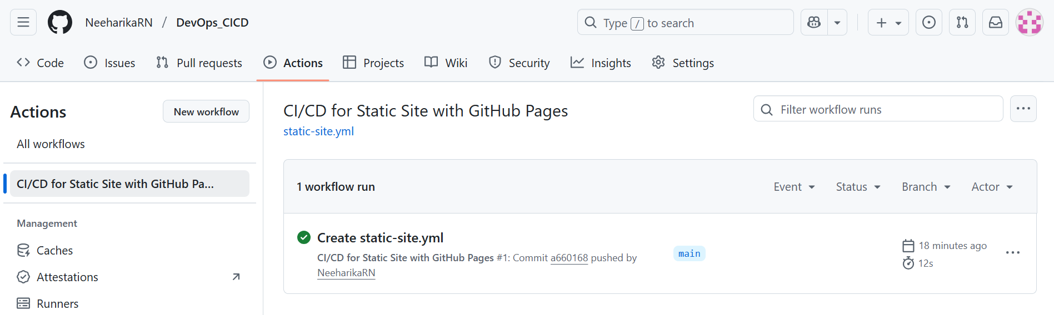  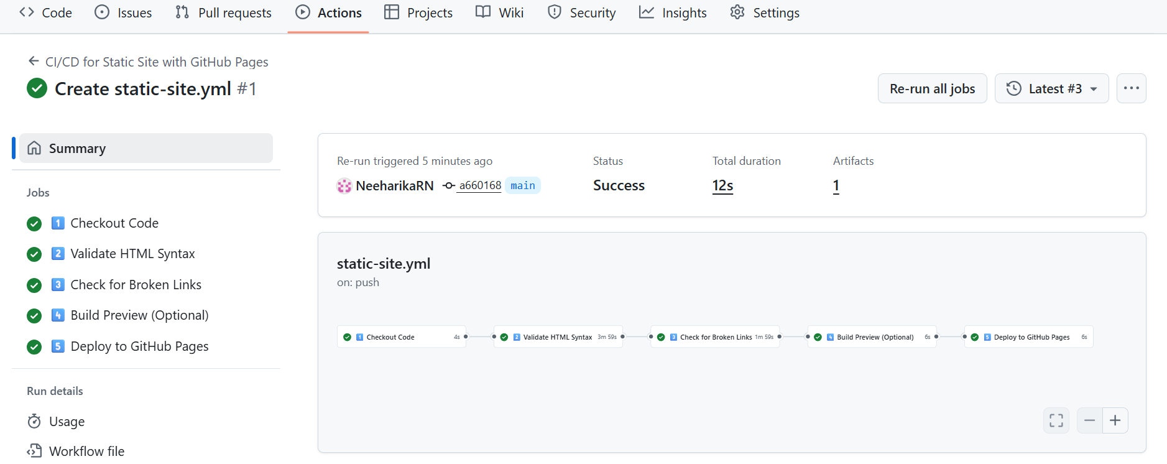  Navigate to “Settings” and from left panel, select “Pages”. Under “Build and Deployment”, select “Deploy from a branch”. Under branch, select “gh-pages” and “/docs”. Click on “Save”.  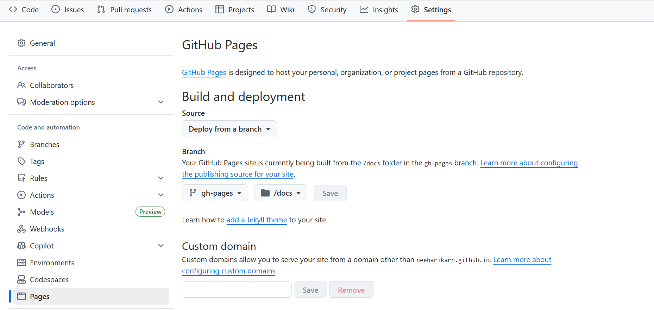  After few minutes, you will get your site URL. Click on “Visit site” and view the website.  